LOW LEVEL DESIGN
FOR
Expense Claim Module

Prepared by/ Modified by |  | Role |  | Start Date – End Date
Prajwal N |  | Team Lead |  | 04 Dec 2018 –  12 Dec 2018
Srinidhi L N |  | Configuration Manager |  | 04 Dec 2018 –  12 Dec 2018
Ashwija Shetty M  Bindu  Vaishnavi M  Jami Sai Bandhavi |  | Developer |  | 04 Dec 2018 –  12 Dec 2018
Jeevan R  Muthu Raj. S  Akshay.K  Radha Vennapusa |  | Designer |  | 04 Dec 2018 –  12 Dec 2018
Reviewed by |  | Role |  | Date of Review
Tanmaya and Uma |  |  |  | 13 Dec 2018
Approved by |  | Role |  | Date of Approval
Vaishali
Circulation List | To all the ELTP mentors and the applicable trainee teams |  | Version number of the template | V1.0
Version number of the work product | V1.0

Table of Contents

1. Description Of The Unit 3
2. References 4
3. Dependencies / Assumptions 5
4. Class Diagrams 6
5. Sequence Diagrams 7
6. Design Components 8
6.1 List Of UI Components 8
6.2 List Of Design Classes 8
7. Re-Usable Routines/Components 9
8. Messages 10
9. Configuration Files 11
10. Crud Matrix Table 12
11. Data Mapping Matrix 13
12. Action Flow Matrix 14
13. Stored Procedures 15
14. Program Specification / Pseudo Code 16
REVISION HISTORY OF THE WORK PRODUCT 17

Description Of The Unit

The Expense Code module allows user to add, delete, update and view the expense details.

On clicking on the add button in the home page, the user is redirected to a add page. The user enters all the details of the expense like expense Code, expense description, expense type. If the entered expense details are invalid, appropriate error messages are displayed.

After entering all the expense details, the details are inserted into the database on clicking the add button. If user wants to delete any expense details by using expense code it will delete automatically, if user clicks on delete button. If user wants to update the expense details, user needs to enter the expense code and click on update button. It will update the expense details of the respective expense details. User can also view the Expense details by entering the expense code.

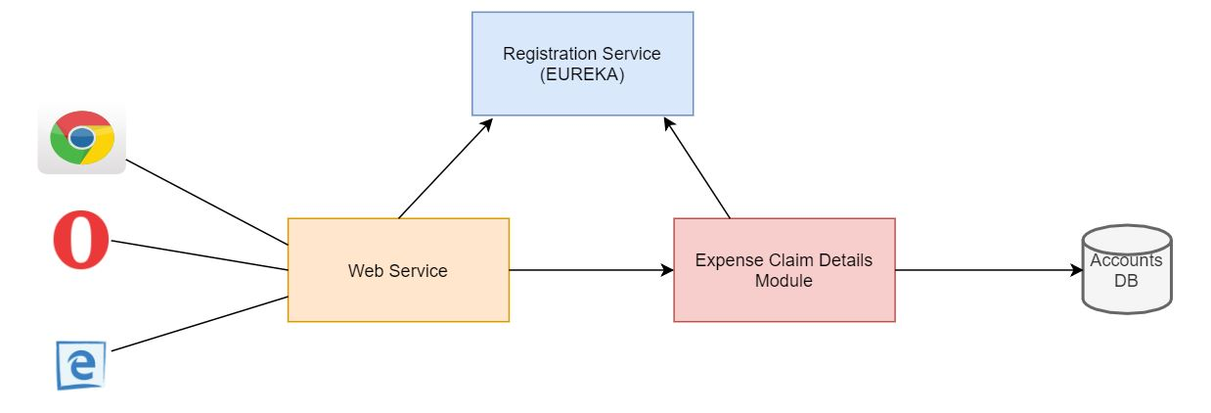

References

Reference | Description
Class Diagram | /Project Documents/Design Documents/HLD/Class Diagrams
DB Design | /Project Documents/Design Documents/HLD/DB Design/ExpenseClaimModule.html

Dependencies / Assumptions
Dependencies:
The user can claim the expense details.

Assumptions:
User entered expense code details are stored in the database.

Class Diagrams

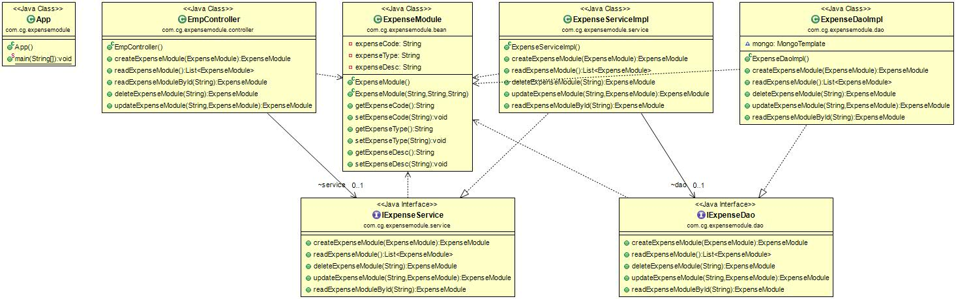

Use Case Diagrams

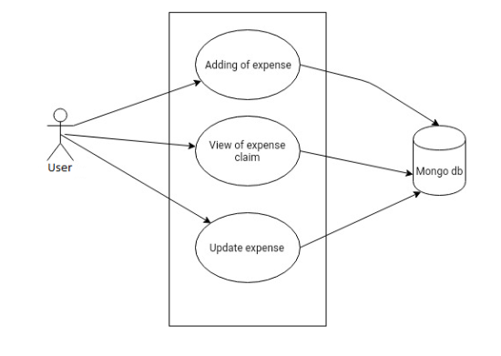

Design Components

List Of UI Components
N/A

List Of Design Classes

Sr. No. | LLD Name | Class Name | Method Name | Method Description
1 | Expense Claim Code Module | ExpenseModule | Appropriate getters and setters methods | Getters retrieve the property values and setters set the property values
2 | Expense Claim Code Module | ExpenseController | createExpenseModule(@Valid @RequestBody ExpenseModule expense):ExpenseModule  readExpenseModule():List<ExpenseModule>  readExpenseModuleById(@PathVariable String expenseCode):ExpenseModule  deleteExpenseModule(@PathVariable String expenseCode):expenseModule  updateExpenseModule(@PathVariable String expenseCode,@RequestBody ExpenseModule expenseModule):ExpenseModule | To perform CRUD operation
3 | Expense Claim Code Module | ExpenseServiceImpl | createExpenseModule(ExpenseModule expense):ExpenseModule  readExpenseModule():List<ExpenseModule>  readExpenseModuleById(String expenseCode):ExpenseModule  deleteExpenseModule(String expenseCode):expenseModule  updateExpenseModule(String expenseCode,expenseModule):ExpenseModule | Calls methods of ExpenseDAOImpl class and returns the result to controller.  .
4 | Expense Claim Code Module | ExpenseDaoImpl | createExpenseModule(ExpenseModule expense):ExpenseModule  readExpenseModule():List<ExpenseModule>  readExpenseModuleById(String expenseCode):ExpenseModule  deleteExpenseModule(String expenseCode):expenseModule  updateExpenseModule(String expenseCode,expenseModule):ExpenseModule | Retrieves the data o from the database and stores in a list.  Inserts the expense details into the database and returns the result to ExpenseServiceImpl.

Re-Usable Routines/Components

Re-Usable Routines/Components

- Jsp files
- DataAccessException class
- Database properties files
- Logger properties files

Messages

#. | Type | Message Text
1. | Error | Expense type should be min of 3 and max of 15 !
2. | Error | Expense Description should be min of 15 and max of 100
3. | Exception | Exception code is not available

Configuration Files

File Name | Path | Description
application.yml | /ExpenseClaimCodeModule | Eureka configurations
application.properties | /ExpenseModule/resources | Database configurations

Crud Matrix Table

# | Table Name | Create | Read | Update | Delete
1. | ExpenseDetails | Y | Y | Y | Y

Data Mapping Matrix

Sr. No. | Screen Label | Field Source | Field Type | Data Type | Max Length | Data Flow | Mandatory
1 | Expense code | ExpenseModule.Expensecode | TextBox | String | NA | UI | Yes
2 | ExpenseType | ExpenseModule.expensetype | TextBox | String | 15 | UI→D | Yes
3 | Expensedescription | ExpenseModule.expensedescription | Textbox | String | 100 | UI->D | Yes

Legend
D → UI (Database to User Interface)
UI → D (User Interface to Database)
UI (User Interface Only)

Action Flow Matrix

Sr. No. | Action | Description | Process
1 | On click of Add Button in Homepage | The expense details are inserted into the database | Data is entered in the fields by the user which gets inserted into the database when add button is pressed.
2 | On click of Delete button in home page | The expense details are deleted from the database. | Data is deleted from the database when delete button is pressed.
3 | On click of Update button in Home page | The expense is updated into the database. | Data is updated into the database when update button is pressed.
4 | On click of View button in Home page | The expense details are displayed from the database. | Data is selected from the database when view button is pressed.

Stored Procedures

# | Stored Procedure Name  (with Description) | Input/Out Parameters | Type | Size
1. | NA | NA | NA | NA

Program Specification / Pseudo Code

<ACTION :ADD_CLICK >

Pseudo Code:
- Client Side Scripting:
None

- Server Side Scripting:
BEGIN
Call ExpenseModule(Model model) in Controller class
Navigate to ExpenseModule page
END

14. 1 <ACTION: AddExpenseModule_CLICK>

Pseudo Code:

- Client Side Scripting:

IF invalid expense Type
Print Error Message M1
IF invalid expense description
Print Error Message M2

- Server Side Scripting:
BEGIN
Call @RequestMapping(value = "/create",method=RequestMethod.POST)
public ExpenseModule createExpenseModule(@Valid @RequestBody ExpenseModule expense) in Controller class in Presentation Layer
BEGIN
Call addExpenseCode (ExpenseCode expenseCode) in ExpenseCodeImpl class in Service Layer
BEGIN
Call addExpenseCode (ExpenseCode expenseCode)in ExpenseDAOImpl class class in Data Access Layer
BEGIN
Create query for insert records into Expense and Expense_details table
Return Expense value.
END
Return Expense value to Service Layer
END
Return Expense value to Presentation Layer

END
IF successful navigate to home page
Else navigate to add page and show error.
END

<ACTION :UPDATE_CLICK >

Pseudo Code:
1. Client Side Scripting:
None

2.Server Side Scripting:
BEGIN
Call ExpenseModule(Model model) in Controller class
Navigate to ExpenseModule page
END

14. 2 <ACTION: UpdateExpenseModule_CLICK>

Pseudo Code:

1. Client Side Scripting:
None

- Server Side Scripting:
BEGIN
Call @RequestMapping(value = "/update",method=RequestMethod.PUT)
public ExpenseModule updateExpenseModule(@Valid @RequestBody String expenseCode) in Controller class in Presentation Layer
BEGIN
Call updateExpenseCode (String expenseCode) in ExpenseCodeImpl class in Service Layer
BEGIN
Call updateExpenseCode (String expenseCode)in ExpenseDAOImpl class class in Data Access Layer
BEGIN
Create query for update records into Expense and Expense_details table
Return Expense value.
END
Return Expense value to Service Layer
END
Return Expense value to Presentation Layer

END
IF successful navigate to home page
Else navigate to add page and show error.
END

<ACTION :DELETE_CLICK >

Pseudo Code:
1. Client Side Scripting:
None

2.Server Side Scripting:
BEGIN
Call ExpenseModule(Model model) in Controller class
Navigate to ExpenseModule page
END

14. 3 <ACTION: DeleteExpenseModule_CLICK>

Pseudo Code:

1. Client Side Scripting:
None

- Server Side Scripting:
BEGIN
Call @RequestMapping(value = "/delete",method=RequestMethod.DELETE)
public ExpenseModule deleteExpenseModule(@Valid @RequestBody String expenseCode) in Controller class in Presentation Layer
BEGIN
Call deleteExpenseCode (String expenseCode) in ExpenseCodeImpl class in Service Layer
BEGIN
Call deleteExpenseCode (String expenseCode)in ExpenseDAOImpl class class in Data Access Layer
BEGIN
Create query for delete records from Expense_details table
Return Expense value.
END
Return Expense value to Service Layer
END
Return Expense value to Presentation Layer

END
IF successful navigate to home page
Else navigate to add page and show error.
END

<ACTION :VIEW_CLICK >

Pseudo Code:
1. Client Side Scripting:
None

2.Server Side Scripting:
BEGIN
Call ExpenseModule(Model model) in Controller class
Navigate to ExpenseModule page
END

14. 4 <ACTION: ViewExpenseModule_CLICK>

Pseudo Code:

1. Client Side Scripting:
None

- Server Side Scripting:
BEGIN
Call @RequestMapping(value = "/view",method=RequestMethod.GET)
public ExpenseModule viewExpenseModule(@Valid @RequestBody String expenseCode) in Controller class in Presentation Layer
BEGIN
Call viewExpenseCode (String expenseCode) in ExpenseCodeImpl class in Service Layer
BEGIN
Call viewExpenseCode (String expenseCode)in ExpenseDAOImpl class class in Data Access Layer
BEGIN
Create query for view records from Expense and Expense_details table
Return Expense value.
END
Return Expense value to Service Layer
END
Return Expense value to Presentation Layer

END
IF successful navigate to home page
Else navigate to add page and show error.
END

EVISION HISTORY OF THE WORK PRODUCT

# | Date | Version # | Section Changed | Details of changes made | Approved By
1 | 9/12/2018 | 1.0 | LLD prepared | N/A | Vaishali
2 | 10/12/2018 | 1.1 | Reusable components,  Pseudo code | Reusable components added.  The pseudo code is modified as per the specified flow. | Vaishali
3 | 11/12/2018 | 1.2 | Reusable components,  References,  Data Mapping Matrix. | Reusable Components added.  File name with relative path is added in the references section.  The name of text boxes(screen label is changed). | Vaishali
4 | 16/12/2018 | 1.3 | Configuration files,UI Components | Paths of the configuration files is updated and UI components(Screen Shots) added. | Vaishali

